**Early Stage Nail Disease Detection System**

**1. Abstract:**

The **Early Stage Nail Disease Detection System** is a computer vision-based application developed to detect various nail diseases at an early stage using deep learning techniques. This intelligent tool leverages image classification to automatically analyze nail conditions and identify diseases such as fungal infections, psoriasis, and onycholysis with high accuracy.

The system allows users (patients or doctors) to upload a nail image, which is then processed by a Convolutional Neural Network (CNN) model trained on a curated dataset. The system outputs the predicted disease class along with a confidence score and optional suggestions for further diagnosis or treatment.

**Key functionalities include:**

✓ **AI-Powered Nail Disease Classification:** Classifies nail images into categories like healthy, fungal, and other conditions.  
✓ **Image Upload Interface:** Users can upload images easily via a web or mobile interface.  
✓ **Confidence Score Output:** Model displays how confident it is in its prediction.  
✓ **Optional Medical Suggestions:** The system suggests possible actions such as visiting a dermatologist or maintaining nail hygiene.  
✓ **Lightweight UI:** Simple and intuitive interface that can be used without technical knowledge.

This system provides an accessible and efficient method to promote early disease detection, especially in remote or underserved areas, thus enhancing dermatological health outcomes.

**2. Introduction:**

Nail health is an important indicator of both dermatological and systemic health. However, due to lack of awareness or access to healthcare, nail diseases often go undiagnosed until they worsen.

The **Early Stage Nail Disease Detection System** addresses this problem using a deep learning approach. It utilizes CNN-based image classification to diagnose nail-related diseases from input images and provides an immediate, automated assessment.

The primary goal is to assist users in identifying potential problems early, reducing the need for delayed and expensive treatments. The system is suitable for integration into mobile health apps, telemedicine platforms, and can even be used by dermatologists for second opinions.

**3. Data Flow Diagram (DFD):**

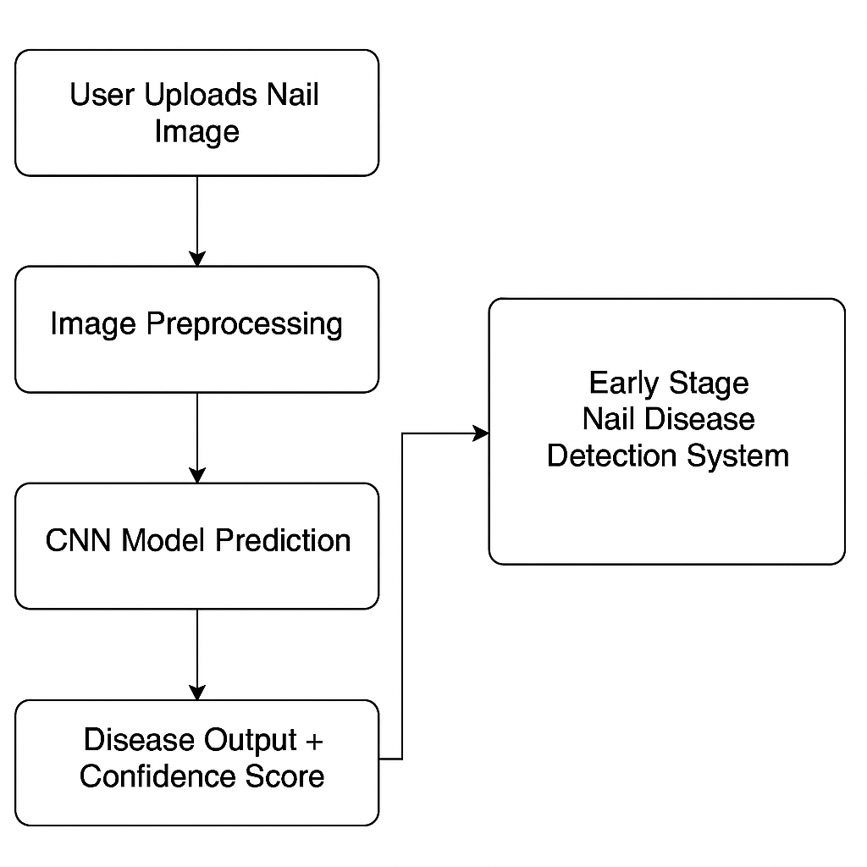

**4. Use Case Diagram:**

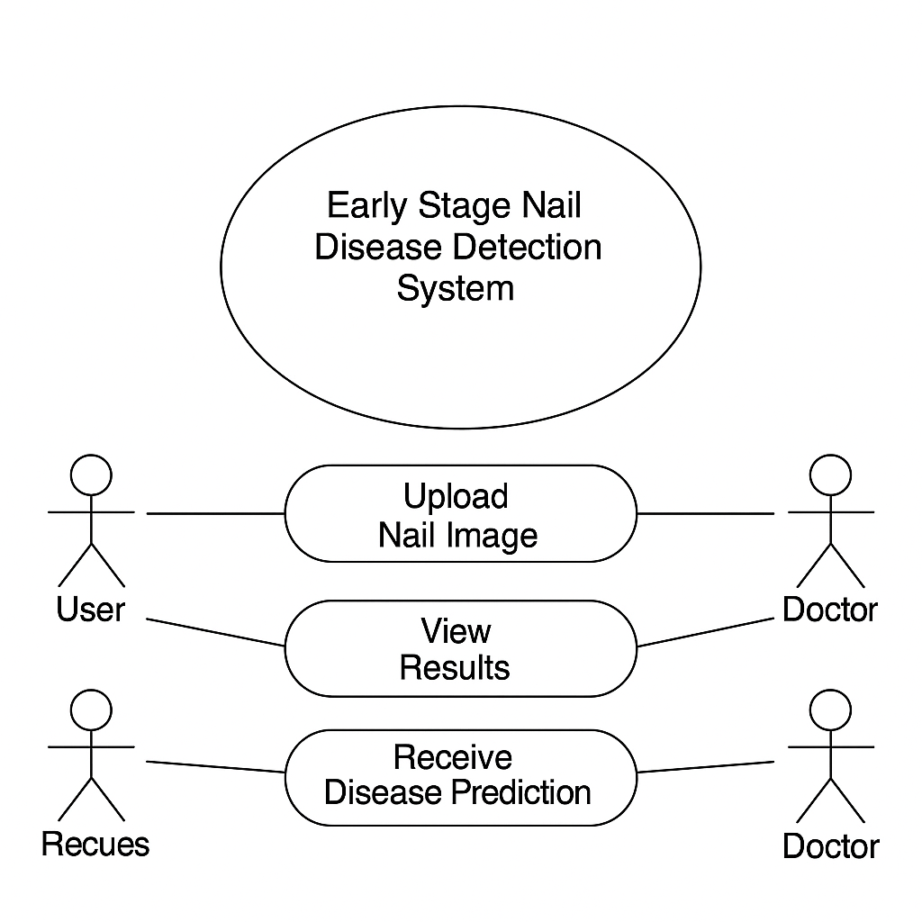

### ****5. Software Requirements:****

#### a) Operating System:

* Windows / Linux / Android / Web Browsers

#### b) Hardware Requirements:

* Minimum: 4GB RAM, Dual-core processor
* Recommended: 8GB RAM with GPU for model training

#### c) Software Requirements:

* **Programming Language:** Python
* **Libraries:** TensorFlow/Keras, OpenCV, NumPy, Pandas, Matplotlib
* **IDE:** Jupyter Notebook or VS Code
* **Web Framework:** Flask / Streamlit
* **Dataset:** Labeled nail image dataset (custom or from Kaggle)
* **Version Control:** Git and GitHub for project tracking

### ****6. Sample Model Architecture:****

* **Input Size:** 224x224x3 (RGB image)
* **Layers:**
  + Convolutional layers with ReLU
  + MaxPooling
  + Dropout
  + Flatten
  + Dense layers
  + Softmax output layer
* **Output:** Predicted disease class (e.g., Healthy, Fungal, Psoriasis)

### ****7. Outputs:****

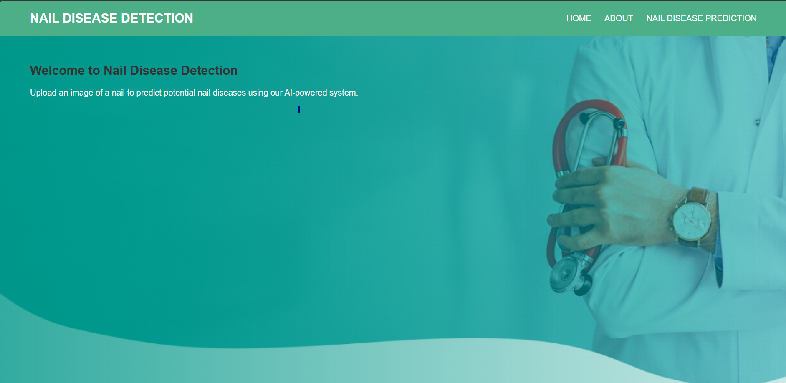

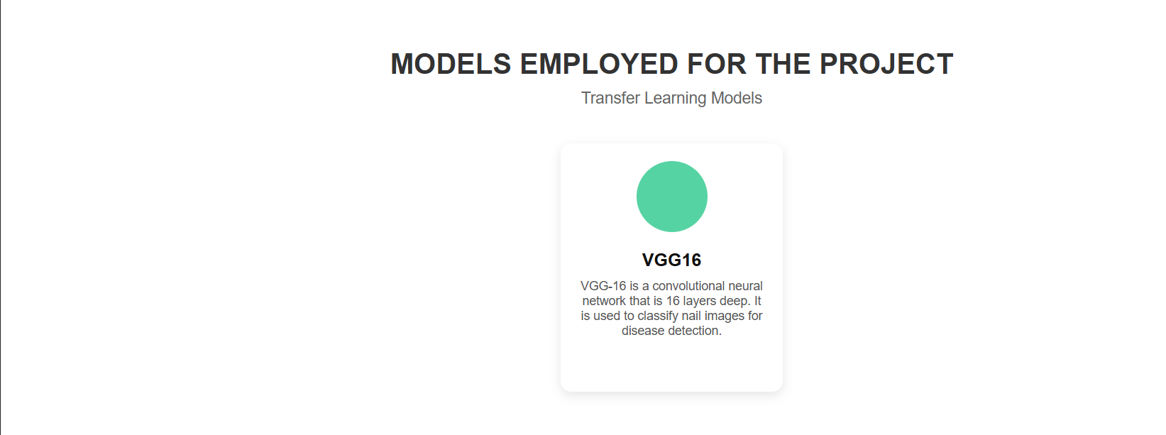

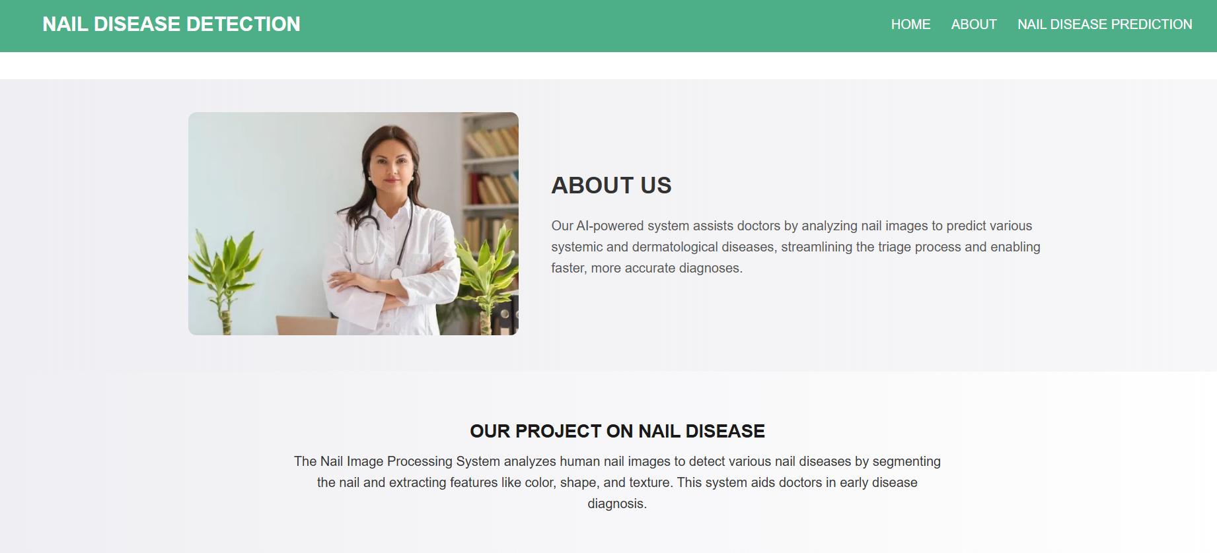

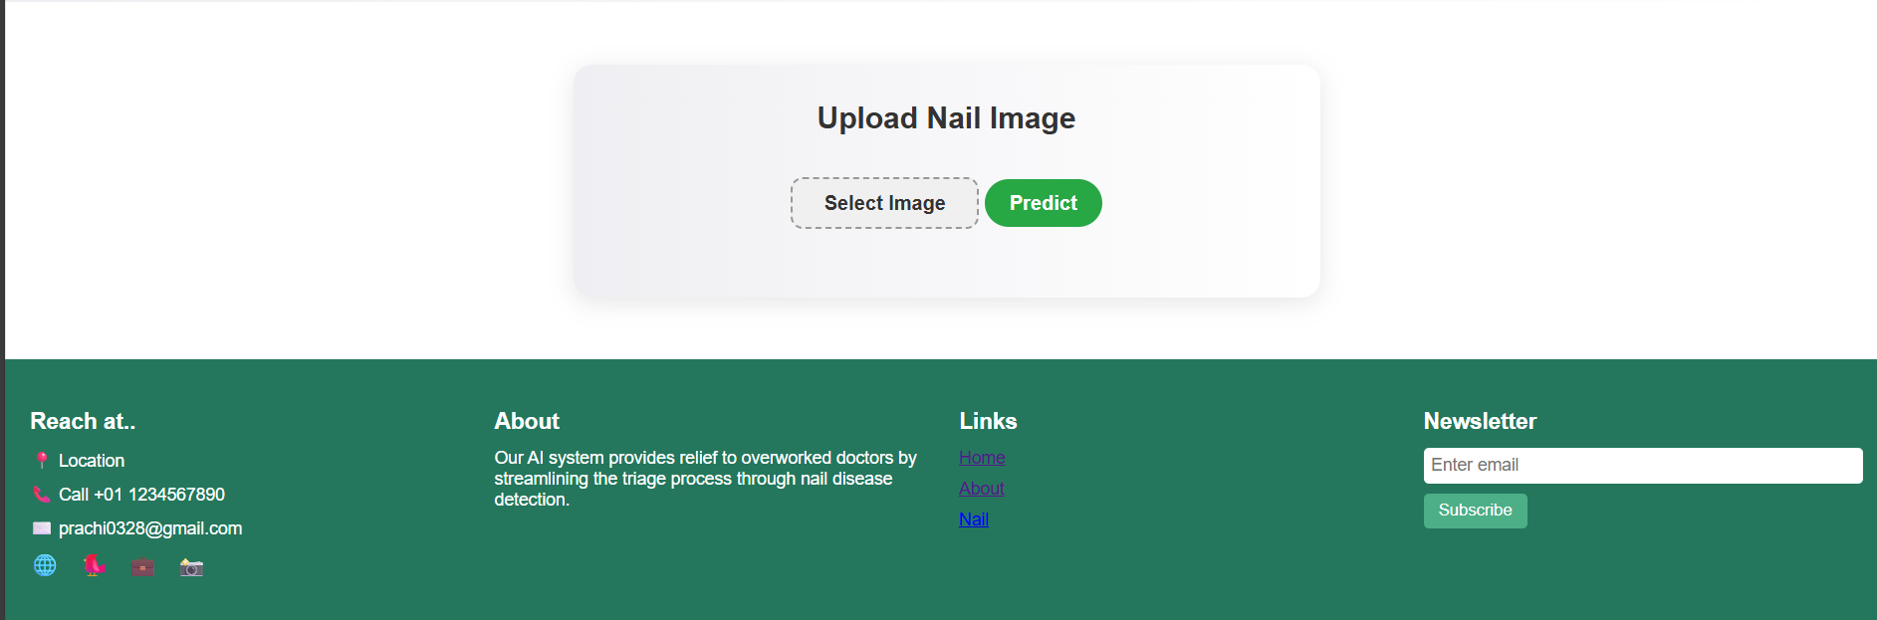

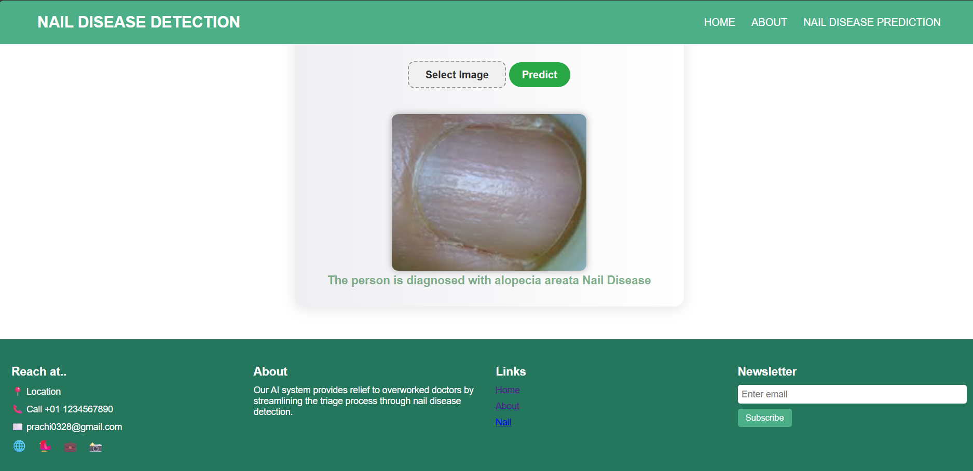

### ****8. Conclusion:****

The **Early Stage Nail Disease Detection System** provides a modern, intelligent solution for preliminary diagnosis of nail disorders using deep learning. By enabling users to detect potential issues through a simple image upload, it minimizes the need for immediate clinical visits and promotes early treatment.

The system is effective, accessible, and scalable for both individual users and healthcare institutions. It demonstrates how artificial intelligence can be applied to improve dermatological diagnostics and overall health outcomes, especially in underdiagnosed communities.

### ****9. Future Enhancement:****

To ensure continuous improvement and broader adoption, the following enhancements are planned:

* **Expanded Dataset:** Incorporate more nail images across different skin tones and lighting conditions.
* **Mobile App Integration:** Android/iOS apps for real-time scanning.
* **Doctor Dashboard:** Allow doctors to manage patients and predictions.
* **Explainable AI (XAI):** Use Grad-CAM to highlight infected areas in predictions.
* **Voice Assistant:** Enable voice-guided image capture and feedback.
* **User History Tracking:** Store predictions for long-term health monitoring.
* **Multilingual Support:** Translate app UI into regional and international languages.
* **Cloud Deployment:** Host model and app on cloud for remote diagnosis.
* **Security Enhancements:** Encrypt all uploaded images and ensure compliance with data protection standards.
* **Integration with Wearables:** Use smart cameras for live nail scanning.